

**AMERICAN INTERNATIONAL UNIVERSITY-BANGLADESH**

**Faculty of Engineering**

Lab Report

**Experiment # 00**

**Experiment Title: Write down the experiment title here.**

|  |  |  |  |
| --- | --- | --- | --- |
| **Date of Perform:** |  | **Date of Submission:** |  |
| **Course Title:** | MICROPROCESSOR AND EMBEDDED SYSTEMS LAB | | |
| **Course Code:** | COE3104 | **Section:** |  |
| **Semester:** |  | **Degree Program:** | BSc in CSE/BSc in EEE |
| **Course Teacher:** | **Write the course teacher name here** | | |

**Declaration and Statement of Authorship:**

1. I/we hold a copy of this Assignment/Case-Study, which can be produced if the original is lost/damaged.
2. This Assignment/Case-Study is my/our original work and no part of it has been copied from any other student’s work or from any other source except where due acknowledgment is made.
3. No part of this Assignment/Case-Study has been written for me/us by any other person except where such collaboration has been authorized

by the concerned teacher and is clearly acknowledged in the assignment.

1. I/we have not previously submitted or currently submitting this work for any other course/unit.
2. This work may be reproduced, communicated, compared, and archived for the purpose of detecting plagiarism.
3. I/we give permission for a copy of my/our marked work to be retained by the Faculty Member for review by any internal/external examiners.
4. I/we understand that Plagiarism is the presentation of the work, idea, or creation of another person as though it is your own. It is a form of cheating and is a very serious academic offense that may lead to expulsion from the University. Plagiarized material can be drawn from, and presented in, written, graphic and visual forms, including electronic data, and oral presentations. Plagiarism occurs when the origin of the source is not appropriately cited.
5. I/we also understand that enabling plagiarism is the act of assisting or allowing another person to plagiarize or copy my/our work.

*\* Student(s) must complete all details except the faculty use part.*

** Please submit all assignments to your course teacher or the office of the concerned teacher.

|  |  |  |  |  |
| --- | --- | --- | --- | --- |
| **Group # 00** | | | | |
|  |  |  |  |  |
| **Sl No** | **Name** | **ID** | **PROGRAM** | **SIGNATURE** |
| 1 |  |  | BSc in CSE |  |
| 2 |  |  |  |  |
| 3 |  |  |  |  |
| 4 |  |  |  |  |
| 5 |  |  |  |  |
| 6 |  |  |  |  |

|  |  |  |
| --- | --- | --- |
| ***Faculty use only*** | | |
| FACULTY COMMENTS | **Marks Obtained** |  |
|  |
| **Total Marks** |  |

# Table of Contents

|  |  |
| --- | --- |
| Experiment Title | 3 |
| Objectives | 3 |
| Equipment List | 3 |
| Circuit Diagram | 4 |
| Code/Program | 5 |
| Hardware Output Results | 6 |
| Experimental Output Results | 7 |
| Simulation Output Results | 8 |
| Answers to the Questions in the Lab Manual | 9 |
| Discussion | 12 |
| References | 13 |

Experiment Title: Write down the title here.

# Objectives:

The objectives of this experiment are to-

1. Experiment objectives go here

# Equipment List:

1. Arduino board
2. Breadboard
3. LED lights (red, yellow, green)
4. Jumper wires

# Circuit Diagram:

The Arduino platform is made up of the following components.

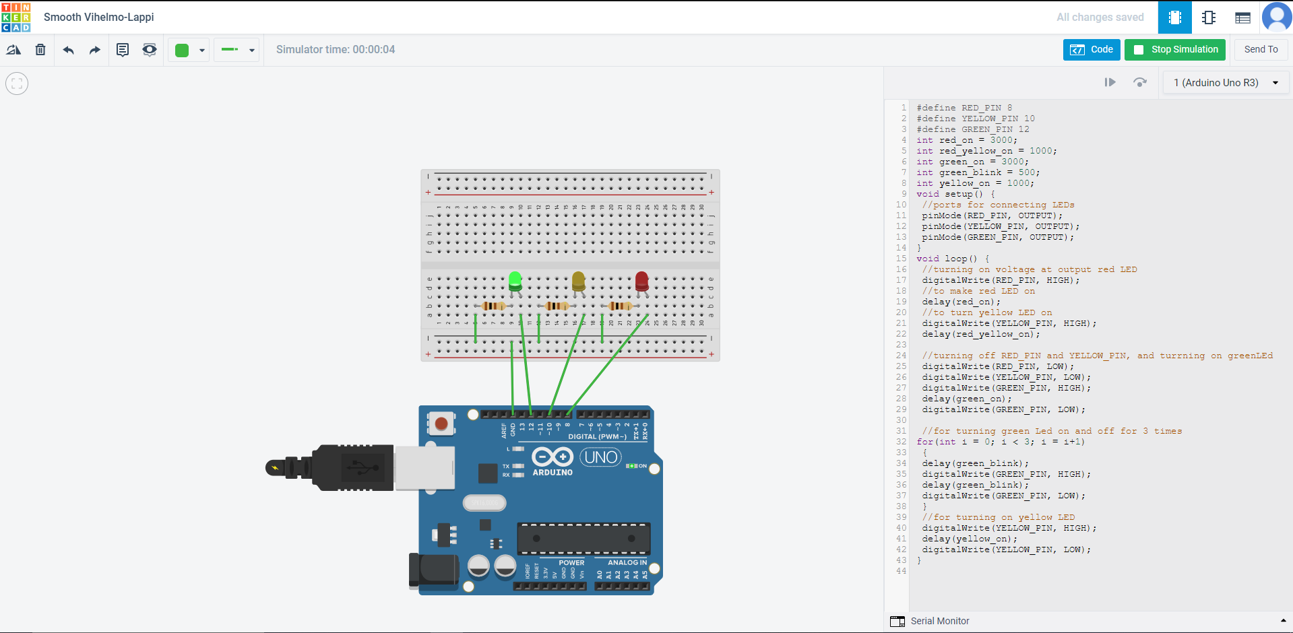

Fig. 1 Hardware circuit diagram of a sample project using TinkerCad

# Code/Program:

Please provide here the codes and explain the codes line by line

**Hardware Output Results:**

Please provide here the hardware results or outputs in the form of images and explain them

**Experimental Output Results:**

Please provide here the experimental results or outputs in the form of images, data, or graphs, and explain how you got the results using which environment and tools.

**Simulation Output Results:**

Please provide here the simulation results or outputs in the form of images and explain how you got the simulation in Proteus or any other environment.

**Answers to the Questions in the Lab Manual:**

Please provide here the answers to the questions at the end of the lab manual.

# Discussion:

Discuss here what you have obtained and how much experience you could achieve.

# References:

1. List the references here from where you can find your answers for this report.
2. ….